OS EXPT 6

NAME – SAHIL BISWAS

ROLL NUMBER 16010422013

BATCH: A1

CODE:

import matplotlib.pyplot as plt

# Process class

class Process:

    def __init__(self, pid, burst_time):

        self.pid = pid

        self.burst_time = burst_time

        self.remaining_time = burst_time

        self.waiting_time = 0

        self.turnaround_time = 0

# Gantt chart drawing function

def draw_gantt_chart(gantt_chart):

    plt.figure(figsize=(10, 2))

    for idx, (pid, start, end) in enumerate(gantt_chart):

        plt.barh(0, end - start, left=start, edgecolor='black', color='lightblue')

        plt.text(start + (end - start) / 2, 0, f'P{pid}', va='center', ha='center', color='black')

    plt.xlabel('Time')

    plt.yticks([])

    plt.title('Gantt Chart')

    plt.show()

# Average time calculation

def calculate_avg_times(processes):

    total_waiting_time = sum([p.waiting_time for p in processes])

    total_turnaround_time = sum([p.turnaround_time for p in processes])

    avg_waiting_time = total_waiting_time / len(processes)

    avg_turnaround_time = total_turnaround_time / len(processes)

    return avg_waiting_time, avg_turnaround_time

def round_robin(processes, quantum):

    time = 0

    gantt_chart = []

    ready_queue = processes[:]

    waiting_queue = []

    while ready_queue or waiting_queue:

        if ready_queue:

            current_process = ready_queue.pop(0)

            if current_process.remaining_time > quantum:

                gantt_chart.append((current_process.pid, time, time + quantum))

                time += quantum

                current_process.remaining_time -= quantum

                ready_queue.append(current_process)

            else:

                gantt_chart.append((current_process.pid, time, time + current_process.remaining_time))

                time += current_process.remaining_time

                current_process.turnaround_time = time

                current_process.waiting_time = current_process.turnaround_time - current_process.burst_time

        else:

            time += 1  # Idle CPU time if no processes in ready queue

    draw_gantt_chart(gantt_chart)

    avg_waiting_time, avg_turnaround_time = calculate_avg_times(processes)

    return avg_waiting_time, avg_turnaround_time

def sjf(processes):

    time = 0

    gantt_chart = []

    ready_queue = sorted(processes, key=lambda p: p.burst_time)

    while ready_queue:

        current_process = ready_queue.pop(0)

        gantt_chart.append((current_process.pid, time, time + current_process.burst_time))

        time += current_process.burst_time

        current_process.turnaround_time = time

        current_process.waiting_time = current_process.turnaround_time - current_process.burst_time

    draw_gantt_chart(gantt_chart)

    avg_waiting_time, avg_turnaround_time = calculate_avg_times(processes)

    return avg_waiting_time, avg_turnaround_time

def create_processes():

    return [

        Process(pid=1, burst_time=10),

        Process(pid=2, burst_time=5),

        Process(pid=3, burst_time=8),

        Process(pid=4, burst_time=6),

    ]

if __name__ == "__main__":

    processes_rr = create_processes()

    quantum = 3

    print("Round Robin Scheduling:")

    avg_waiting_rr, avg_turnaround_rr = round_robin(processes_rr, quantum)

    print(f"Average Waiting Time (RR): {avg_waiting_rr:.2f}")

    print(f"Average Turnaround Time (RR): {avg_turnaround_rr:.2f}")

    processes_sjf = create_processes()

    print("\nShortest Job First Scheduling:")

    avg_waiting_sjf, avg_turnaround_sjf = sjf(processes_sjf)

    print(f"Average Waiting Time (SJF): {avg_waiting_sjf:.2f}")

    print(f"Average Turnaround Time (SJF): {avg_turnaround_sjf:.2f}")

OUTPUT:

Round Robin Scheduling:

Average Waiting Time (RR): 17.00

Average Turnaround Time (RR): 24.25

Shortest Job First Scheduling:

Average Waiting Time (SJF): 8.75

Average Turnaround Time (SJF): 16.00

GANTT CHARTS:

ROUND ROBIN:

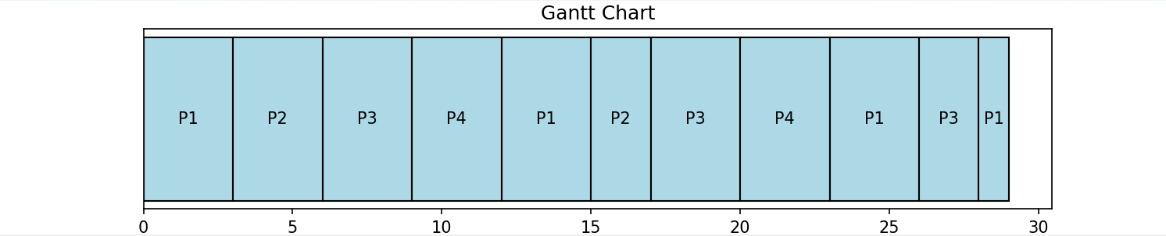

SHORTEST JOB FIRST:

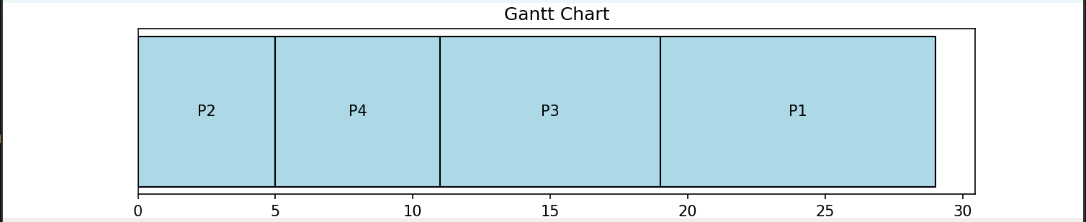

Outcomes: CO2: Demonstrate use of inter process communication

Questions: